Wiltshire Mind Donation Form

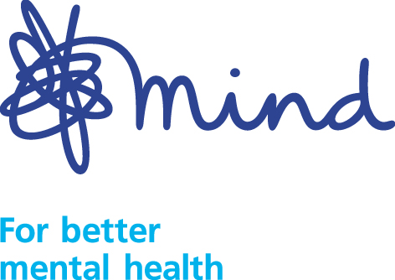

I would like to support the work of Wiltshire Mind with a donation of –

£100 £50 £20 £10 Other £ _____

I enclose a cheque or postal order made payable to Wiltshire Mind.

If you would like to make a regular monthly payment to Wiltshire Mind,
please telephone Alison Hill on 01225 706532 to discuss arrangements with us.

Name: _____________________________

THANK YOU

Your gift will help Wiltshire Mind continue working to improve the lives of people labelled, diagnosed or treated as mentally ill.

Address: _____________________________

_____________________________

_____________________________

Postcode: _____________________________

e-mail: ______________________________

YOUR GIFT AID DECLARATION
Make an even bigger contribution at no cost to you.

Gift Aid allows us to claim tax back on all your donations. For every £1 you give, HMRC will add on an extra 25p from your taxes and it doesn’t cost you a penny.
Please sign and date the following declaration (please delete which does not apply) –

- I am a UK taxpayer and would like Wiltshire Mind to treat all donations I make from today, and for the four years previous to this tax year, as Gift Aid donations until I tell you otherwise.
- I am not a UK taxpayer.

I pay sufficient income and /or capital gains tax to equal the amount that Wiltshire Mind will reclaim.

Signed: Date:

