WILTSHIRE MIND GOLF CLASSIC TO BE

HELD AT KINGSDOWN GOLF CLUB ON

THURSDAY 18th MAY 2017
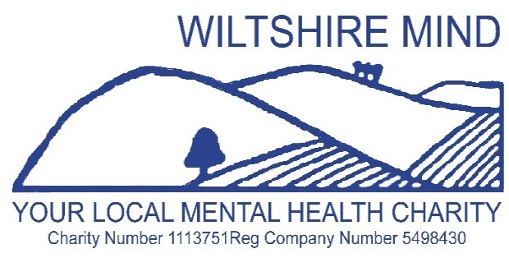
SPONSORED BY

ASHFORD HOMES

FORMAT: SHOTGUN BOWMAKER TEAMS OF 4 LADIES AND MEN
TEE OFF: 12.00
BEST THREE SCORES TO COUNT AT EACH HOLE
MAX: HANDICAP 36 LADIES / 28 MEN
ENTRY £120 VISITOR TEAM or £100 KINGSDOWN MEMBERS TEAM
PRESENTATION OF PRIZES APPROX 16.30
- NAME………………………………………..H/CP……..GOLFCLUB……………………………………….E mail address
- NAME………………………………………..H/CP……..GOLFCLUB……………………………………….E mail address
- NAME………………………………………..H/CP……..GOLFCLUB……………………………………….E mail address
- NAME…………………………………………H/CP …….GOLFCLUB………….…………………………..E mail address
APPLICATIONS TO: J DONALD, 163 BATH ROAD, ATWORTH, WILTS SN12 8JR
TEL: 01225 706641 EMAIL: jdonald226@yahoo.co.uk
CHEQUES MADE PAYABLE TO: WILTSHIRE MIND
WILTSHIRE MIND GOLF CLASSIC TO BE HELD AT KINGSDOWN GOLF CLUB ON THURSDAY 18 MAY
THANK YOU FOR YOUR ENTRY MONIES: YOUR STARTING TEE WILL BE NOTIFIED
FOOD WILL BE AVAILABLE TO PURCHASE IF REQUIRED
PROCEEDS TO WILTSHIRE MIND

