WILTSHIRE MIND GOLF CLASSIC TO BE

HELD AT KINGSDOWN GOLF CLUB ON

THURSDAY 17th MAY 2018
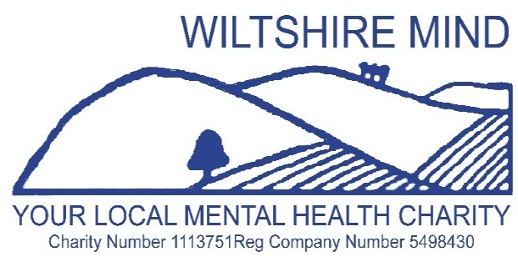
SPONSORED BY

ASHFORD HOMES

FORMAT: SHOTGUN BOWMAKER TEAMS OF 4 LADIES AND MEN
TEE OFF: 1200
BEST THREE SCORES TO COUNT AT EACH HOLE
MAX: HANDICAP 36 LADIES / 28 MEN
ENTRY £120 VISITOR TEAM or £100 KINGSDOWN MEMBERS TEAM
PRESENTATION OF PRIZES approx 1630 Followed by an Auction
- NAME……………………………………… H/CP……. GOLFCLUB……………. E mail ….
- NAME……………………………………… H/CP……. GOLFCLUB……………. E mail …..
- NAME……………………………………… H/CP…… GOLFCLUB……………. E mail …..
- NAME……………………………………… H/CP …… GOLFCLUB………….… E mail ….
APPLICATIONS TO: J DONALD 163 BATH ROAD ATWORTH WILTS SN12 8JR
TEL: 01225 706641 EMAIL: jdonald226@yahoo.co.uk
CHEQUES PAYABLE TO: WILTSHIRE MIND or BACs: Sort 200506 Acc 90135984
WILTSHIRE MIND GOLF CLASSIC TO BE HELD AT KINGSDOWN GOLF CLUB ON THURSDAY 17 MAY
THANK YOU FOR YOUR ENTRY MONIES: YOUR STARTING TEE WILL BE NOTIFIED
FOOD WILL BE AVAILABLE TO PURCHASE IF REQUIRED
ALL PROCEEDS TO WILTSHIRE MIND

