WILTSHIRE MIND GOLF CLASSIC TO BE

HELD AT KINGSDOWN GOLF CLUB ON

THURSDAY 18th MAY 2017

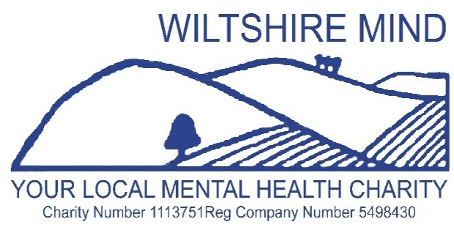



SPONSORED BY

# ASHFORD HOMES

**FORMAT: SHOTGUN BOWMAKER TEAMS OF 4 LADIES AND MEN**

**TEE OFF: 12.00**

**BEST THREE SCORES TO COUNT AT EACH HOLE**

**MAX: HANDICAP 36 LADIES / 28 MEN**

**ENTRY £120 VISITOR TEAM or £100 KINGSDOWN MEMBERS TEAM**

**PRESENTATION OF PRIZES APPROX 16.30**

1. **NAME………………………………………..H/CP……..GOLFCLUB……………………………………….E mail address**
2. **NAME………………………………………..H/CP……..GOLFCLUB……………………………………….E mail address**
3. **NAME………………………………………..H/CP……..GOLFCLUB……………………………………….E mail address**
4. **NAME…………………………………………H/CP …….GOLFCLUB………….…………………………..E mail address**

**APPLICATIONS TO: J DONALD, 163 BATH ROAD, ATWORTH, WILTS SN12 8JR**

**TEL: 01225 706641 EMAIL: jdonald226@yahoo.co.uk**

**CHEQUES MADE PAYABLE TO: WILTSHIRE MIND**

**WILTSHIRE MIND GOLF CLASSIC TO BE HELD AT KINGSDOWN GOLF CLUB ON THURSDAY 18 MAY**

**THANK YOU FOR YOUR ENTRY MONIES: YOUR STARTING TEE WILL BE NOTIFIED**

**FOOD WILL BE AVAILABLE TO PURCHASE IF REQUIRED**

PROCEEDS TO WILTSHIRE MIND